|  |  |
| --- | --- |
| C:\Users\Arfan\Desktop\AI Project\will-stock-markets-soar-20-in-2017-740x431.jpg  Stock Market AnalysisA nd prediction | CSE422  Group Members:  Deep Bose (17241008)  Md. Emteza Alam Bhuiyan (16141004) |

**STOKE MARKET ANALYSIS AND PREDICTION**

**Introduction:**

Trying to predict the stock market is an enticing prospect to data scientists motivated not so much as a desire for material gain, but for the challenge. We see the daily up and downs of the market and imagine there must be patterns we, or our models, can learn in order to beat all those day traders with business degrees. Naturally, when we started using additive models for time series prediction, we had to test the method in the proving ground of the stock market with simulated funds. Inevitably, we joined the many others who have tried to beat the market on a day-to-day basis and failed. However, in the process, we learned a ton of Python including object-oriented programming, data manipulation, modeling, and visualization. we also found out why we should avoid playing the daily stock market without losing a single TK.

**Project Goals:**

Despite its prevalence, Stock Market prediction remains a secretive and empirical art. Few people, if any, are willing to share what successful strategies they have. A chief goal of this project is to add to the academic understanding of stock market prediction. The hope is that with a greater understanding of how the market moves, investors will be better equipped to prevent another financial crisis. The project will evaluate some existing strategies from a rigorous scientific perspective and provide a quantitative evaluation of new strategies.

**DATASET:**

As we are analyzing stoke market and to predict the market for the future we need a huge number of data. We used CL data for our project. Cutter Location (CL) data files are generated from the cutter paths specified within Creo NC NC sequences. Each NC sequence generates a separate CL file. You can also create a single file for a whole operation.

These CL data files can then be passed to machine-specific or generic post-processors for NC tape generation or DNC communications. We use google API as” kTY1NPtwV_HqbB8_hGdU”, we use quandl library for the CL data. We take last 10 years (2007-2017) data from google to predict the market.

**Work flow:**

**Image**

.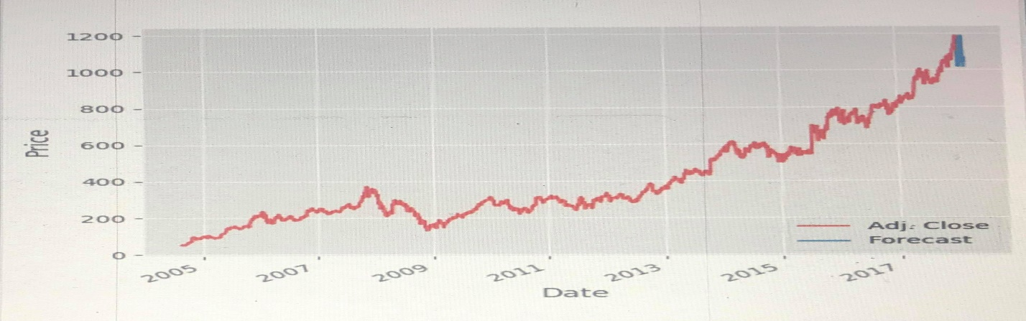

#this is the graph of the last 12 years stoke market price and un and down fall that represents Adj. Close and the prediction is as Forecast.

From the histogram we can predict that the price will fall.

**Conclusion:**

In our project we try to predict the stoke market, whether it will fall or it will grow up at the next day. Al thought we analysis 12 years of data from the google.com and we get the result that it will fall in the near future. Our prediction may be right or wrong, but it will give some idea to the stoke market people to buy and sell their share.

We are now very much interested to go to the future with this project. But from this project we will improve: Effective recognition, Information retrieval, Spam filtering, Fraud detection

**Referance:**

* Gerald R Jensen, Robert R Johnson, and Jeffrey M Mercer. New evidence on size and price-to-book effects in stock returns. *Financial Analysts Jour- nal*, 53(6):34–42, 1997
* Benjamin Graham, David Le Fevre Dodd, and Sidney Cottle. *Security analysis*. McGraw-Hill New York, 1934
* Christopher D Manning, Prabhakar Raghavan, and Hinrich Schütze. *In- troduction to information retrieval*, volume 1. Cambridge university press Cambridge, 2008
* Shunrong Shen, Haomiao Jiang, and Tongda Zhang. Stock market fore- casting using machine learning algorithms, 2012
* EM-DAT the international disaster database. http://www.emdat.be/database. Accessed: 2015-02-26.